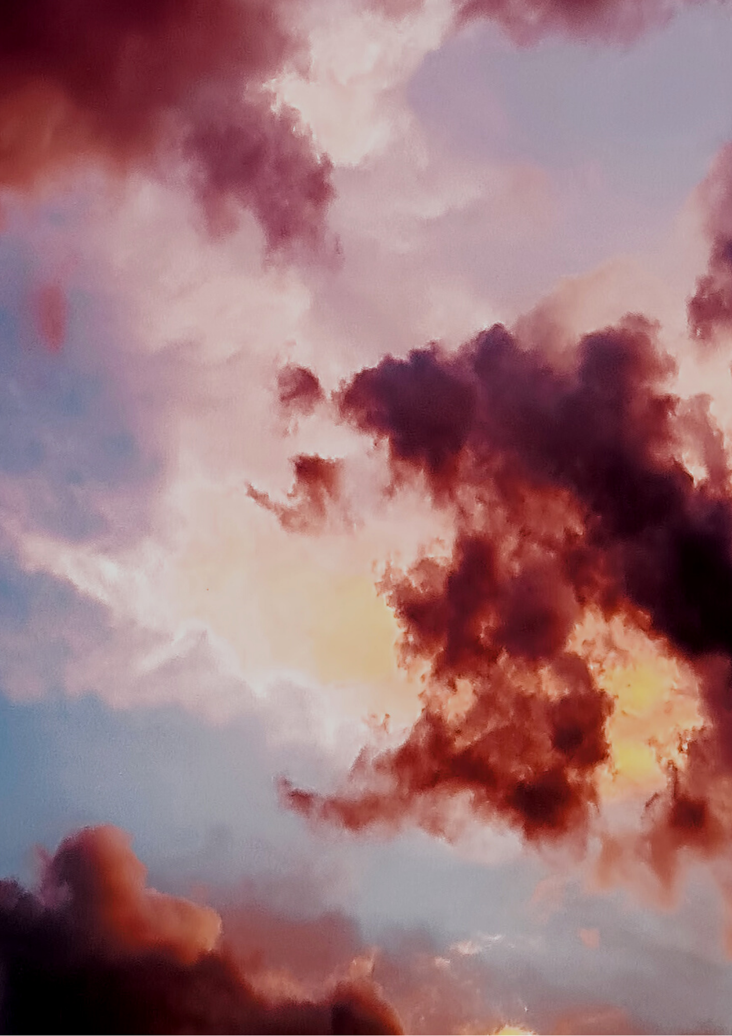


Fort Collins weather and Forest fires

trends and statistics (2008-2015)



Introduction
Weather data can help people navigate their day-to-day lives, but beyond that, long-term weather data can help society track climate change. Fort Collins, Colorado, has been known for its beautiful weather in all four seasons, but more recently it has been known for its devastating forest fires. This pressing exigence has been witnessed firsthand by the people of Fort Collins during the Cameron Peak Fire in 2020, Colorado’s largest wildfire in history (Corey, 2020).

According to Alexa Hmielak of the city of Fort Collins, the last five years has been the hottest year on record. Weather data allows people, governments, and companies to make informed decisions about their response to climate change. For instance, The City of Fort Collins uses data about climate change to develop their “Climate Adaption” plan for the city to prevent damages done by wildfires and flooding in the future (Hmielak, Climate Adaptation || Climate Adaptation).

The Fort Collins Weather Station has kept track of the weather in Fort Collins since 1996. This report is an analysis of the 2008 – 2015 weather data, including each hour of the day, temperature, and wind speed. This report will cover weather trends in Fort Collins and how they might be related to the prevalence of forest fires in the area.

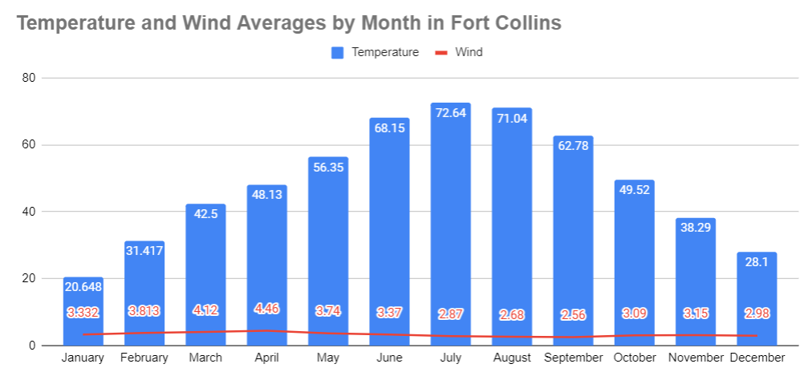

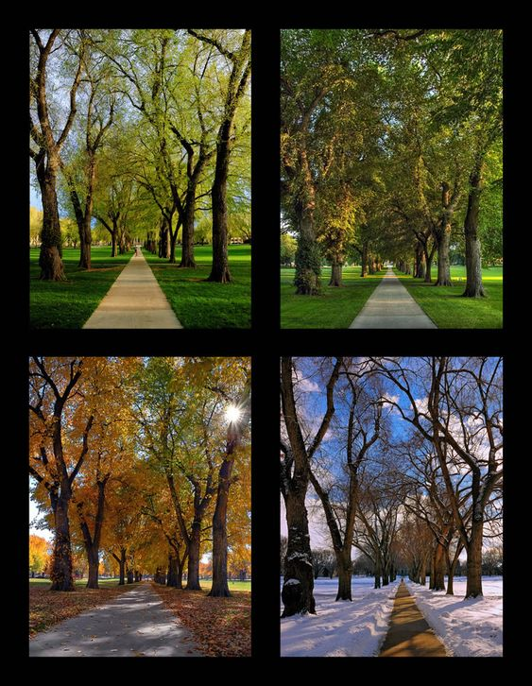
weather and

fire trends

The nationally recognized Oval on the Colorado State University Campus is often photographed and documented all year round, showcasing that each Fort Collins season is beautiful and pleasant in its own way. But with our beautiful summer and fall weather also comes the infamous fire season.
Temperature and wind have a direct correlation with wildfire risk (Neer, 2020). Higher temperatures dry the landscape – and dry foliage makes effective fuel for fires (Neer, 2020). Wind increases a fire’s chance of spreading because it provides additional oxygen as fuel and pushes the embers across distances in unpredictable ways which can spread the fire or start new fires (Neer, 2020).
Figure 1: The Contrast of Seasons in Fort Collins, Colorado. Photos by Michael Menefee (Fort Photo)
The summer high in July averages around 73°, and the winter low in January averages around 21°. Fort Collins is windiest in the spring and least windy in summertime.

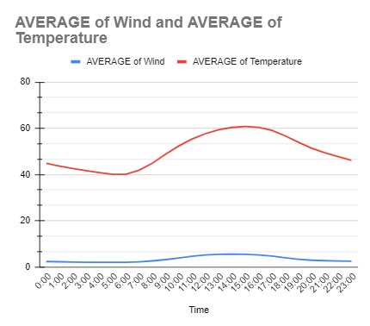
Trends Throughout the day

Throughout the 24-hour day, temperatures reach a low point around 3:00 – 5:00 AM, and it begins increasing until it reaches the high point around 2:00 – 4:00 PM. From the data from the Fort Collins Weather Station, we can see that wind levels tend to increase as the temperature increases and then declines with the temperature in the evening.
According to meteorologist Tom Skilling, wind speed is directly correlated with the warming of the air. When the sun comes up, it warms the surface layer of air on the Earth’s surface. Heat rises, which pushes the higher-level air down to the surface which creates wind. (Skilling, 2015). The increased temperatures and wind in the evening causes wildfires to intensify in the afternoons (Neer, 2020). This same concept is what explains the increase in wind speed during the spring, as the temperature changes from cold to warm, the layers of air in the atmosphere shift.

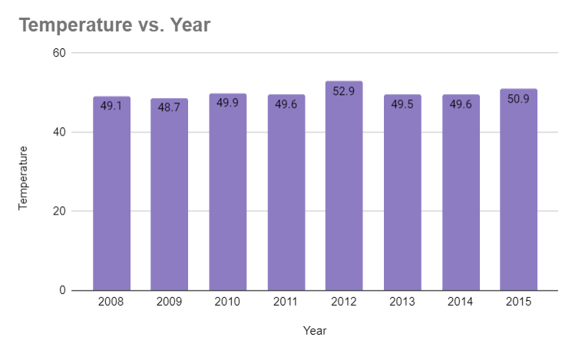
RECORD BREAKERS
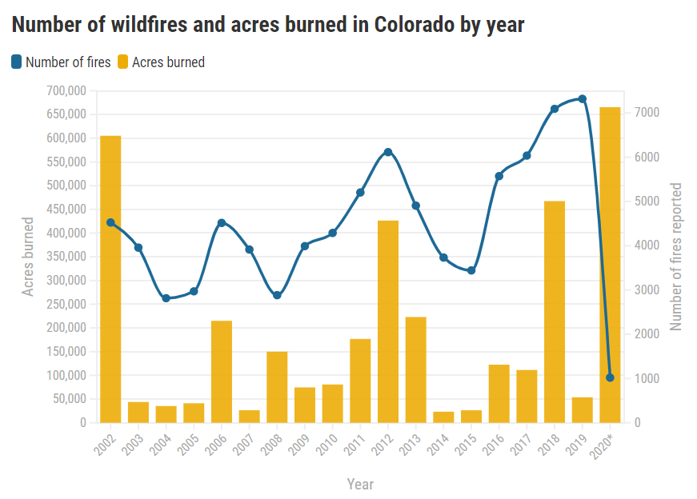
2012 was the hottest year between 2008 and 2013 and included the highest temperature of 99.8°F on June 12th. 2012 also included the windiest day on February 12th, with wind speeds reaching 21.7 mph.
With data retrieved from the Rocky Mountain Area Coordination Center and the data from the Fort Collins Weather Station, we can see a potential correlation between temperature, wind, and forest fires. 2012 is the hottest year and contains record breaking wind speed, which increases that year’s risk for wildfires. That hypothesis can be backed by the significant spike in both number of fires and the acres burned in 2012 (Ingold, 2020). Beyond our data range from the Weather station, we can see a general incline of forest fires more recently, with 2020 having record breaking wildfire rates. This could be reflective of global climate change.
Figure 2: Number of wildfires and acres burned in Colorado by year. Source: Rocky Mountain Area Coordination Center

Conclusion
Humanity is facing one of the most pressing exigencies of history, global climate change. Weather data is more important than ever as governments and people prepare for the effects of increasing temperatures. With this data, we can see a direct correlation within the years 2008 and 2015 between increasing temperatures and increasing wind and the escalating risk of forest fires in and around Fort Collins, Colorado. Weather is one of the few things left that humans have not conquered, but we can use science and data to best respond to it. The first step in inducing action is making gathering and analyzing data. By using science and analyzing data, cities around the globe are creating emergency preparedness plans in order to prevent loss of life and property. Beyond preparing for the worst-case scenarios, society can also use this data to slow the onset of climate change for future generations by reducing greenhouse emissions.

SOURCES
Corey, C. (2020, August 14). Largest fires on record in Colorado history. Retrieved December 09, 2020, from https://www.kjct8.com/2020/08/26/largest-fires-on-record-in-colorado-history/
Fort Collins Weather Station, Fort Collins Weather Station Data Access, Colorado State University, Fort Collins Colorado. http://ccc.atmos.colostate.edu/~autowx/fclwx_access.php. Accessed 2016.
Hmielak, A. (n.d.). Climate Adaptation || Climate Adaptation. Retrieved December 09, 2020, from https://www.fcgov.com/climateadaptation/
Ingold, J. (2020, October 20). Five charts that show where 2020 ranks in Colorado wildfire history. Retrieved December 09, 2020, from https://coloradosun.com/2020/10/20/colorado-largest-wildfire-history/
Neer, K. (2020, January 27). What if a wildfire came near my house? Retrieved December 09, 2020, from https://science.howstuffworks.com/nature/natural-disasters/wildfire-near-my-house1.htm
Skilling, Tom. Dec 19th, 2015. Ask Tom: Why does wind speed increase from morning to afternoon?. Retrieved from https://www.chicagotribune.com/weather/ct-wea-1220-asktom-20151218-column.html. Accessed 2020.

